Admin’s manual

How to verify PLC test connection

For inputting test data, use bre-tfs02\Projects\2015-104554 PTS Alfing\PackageSenderClient

It will compile to PackageSenderClient.exe and PackageSenderClient.exe.config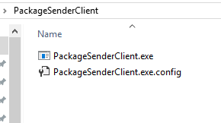

Modify the sender target in the config if necessary, then run the exe.

Enter 311 for the message to send

That’s a Geely StatusUpdate

Enter a random or specific WorkPieceIdentifier to identify the workpiece this StatusUpdate would belong to

Repeat as necessary

If you only test locally, the default config is good enough. It will send messages to localhost at port 5050, where the KPU PTS Server component will listen by default.

Verifying PTS functionality

The test publish will be to BRE-HV03’s SFA cluster.

After the deployment process from VS has ended, check if the PTS server ports are open with netstat.

